Operational Actions
Action | Timeframe | Update
Active engagement from staff when women  are causing disturbances | On-going | Staff continue to intervene and support the women in our care when they are distressed or when causing a disturbance.
Consideration of relocation of women should  the noise level be disturbing | On-going and being taken forward on case-by-  case basis. | This continues to be an option, on a case-by-case basis.
Prioritisation of rooms ‘inward’ facing for  women who are causing noise disturbances | On-going
Re-deployment of experience staff from other Establishments | Complete/Ongoing | This exercise has now been marked as complete, however further considerations will be made if necessary.
Training and support for staff in intervening and supporting women causing disturbances | On-going | Again, we continue to use this intervention when possible.
Compendium of long-term operational considerations being compiled | On-going | In active development.

Improvements to the Physical Estates – all improvements will be continuously monitored for their effectiveness with additional measures sought and considered if required.
Action | Timeframe | Update
Sheeting to be added to fence to remove ability to see through fence | Ordered and will be installed as soon as possible. | Completed.
Post and wire fence and hedging to provide additional aesthetic screening. | Commissioned and to be commenced at earliest opportunity. | Completed.  See Image 3 below.
Additional landscaping internal to the establishment to absorb noise – this  will include increasing the height of earth; and planting hedges. | Commissioned; planting will take place in spring. | Phase 1 landscape planning has begun internally within the establishment. Sound attenuation paneling is complete.  See Image 1, 2 & 3 below.
Introducing forced ventilation to rooms to allow windows to locked | Design has been commissioned; awaiting confirmation of timescales. | Project viability has been assessed. Design and construction phase now being considered, and an indicative timeframe for the project being developed.

Consideration of other parts of the facility to  be recommissioned to allow more spaces for women to be housed. | Commissioned and we will provide further update. | Additional assessment now underway to assess options and determine the best way forward.
Additional car parking for staff and visitors being created increasing capacity to +150  spaces | Additional spaces will be introduced on a phased basis dependent on access to  parts of the site. | 124 parking spaces are available for use as of 3 December, with 34 additional spaces becoming available in the coming weeks. On street public parking in Castle Vale has also been upgraded providing additional spaces.

Monitoring and Communication
Action | Timeframe | Update
SPS to take advice from a professional acoustician on noise level and actions to reduce noise | Complete and actions recommended are included above.  This included the recording of noise being taken and assessed by acoustician. | This is now complete and recommended actions have been included in above updates.
Ongoing monitoring of noise | SPS will take this forward on two fronts:  Staff will take written notes to detail disturbances.  We will, on a regular basis, instruct for formal noise recording as previously undertaken to provide on-going record. | Staff continue to monitor, taking appropriate action as necessary.  Acoustic survey completed; appropriate next steps are now being considered.
Regular communication with neighbours | Updates will be placed on website.  Specific email address for neighbours to contact: HQEnquiries@prisons.gov.scot | Please note change of contact email address to HQEnquiries@prisons.gov.scot

IMAGE 1

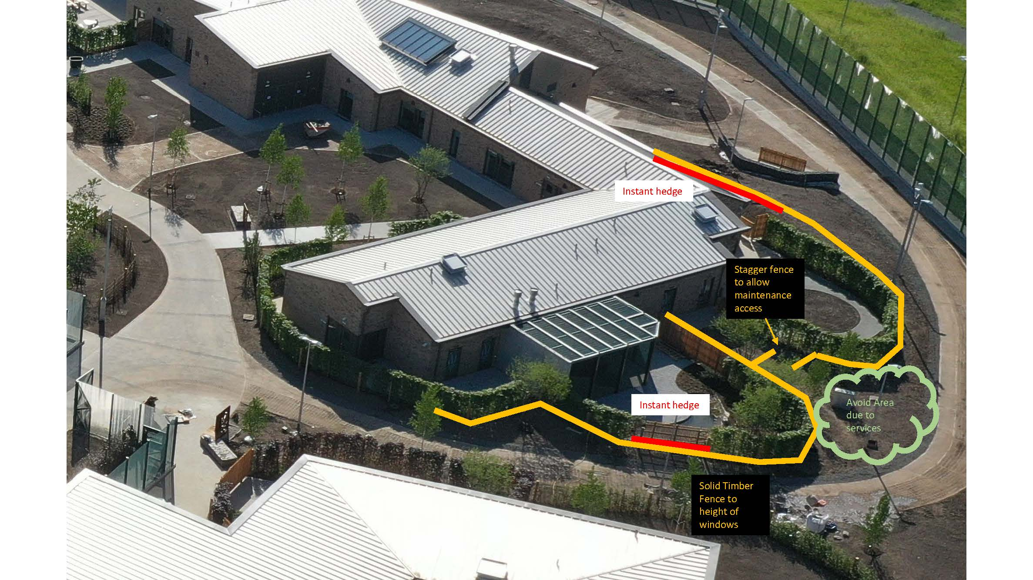

IMAGE 2

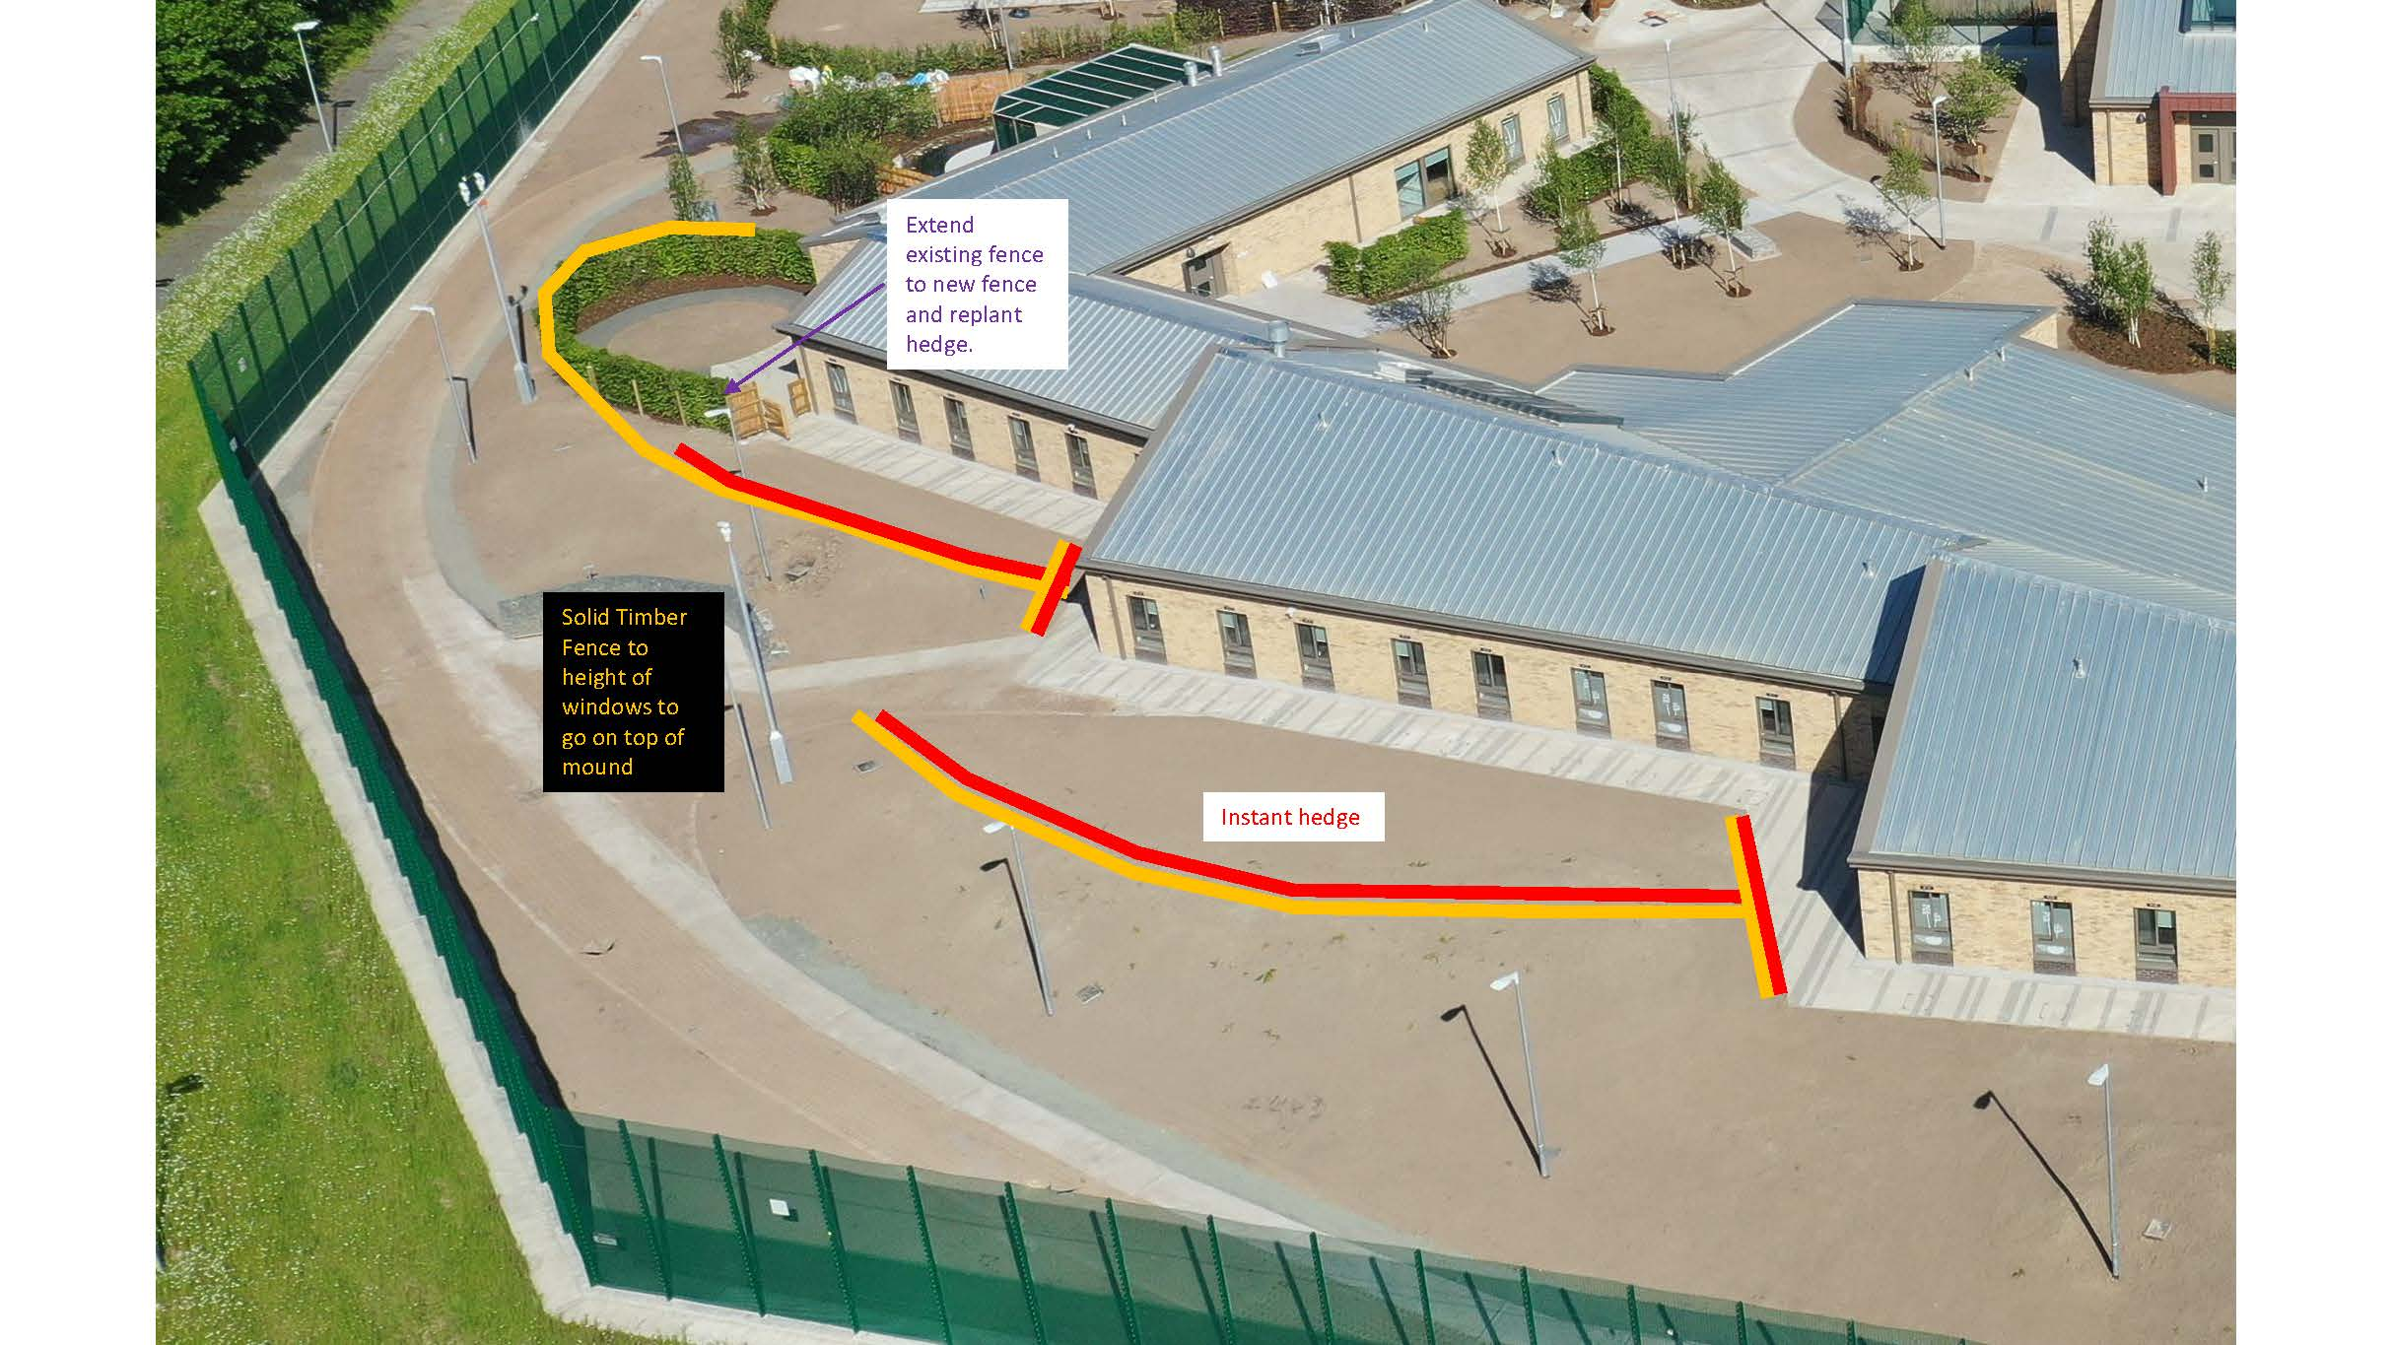

IMAGE 3

